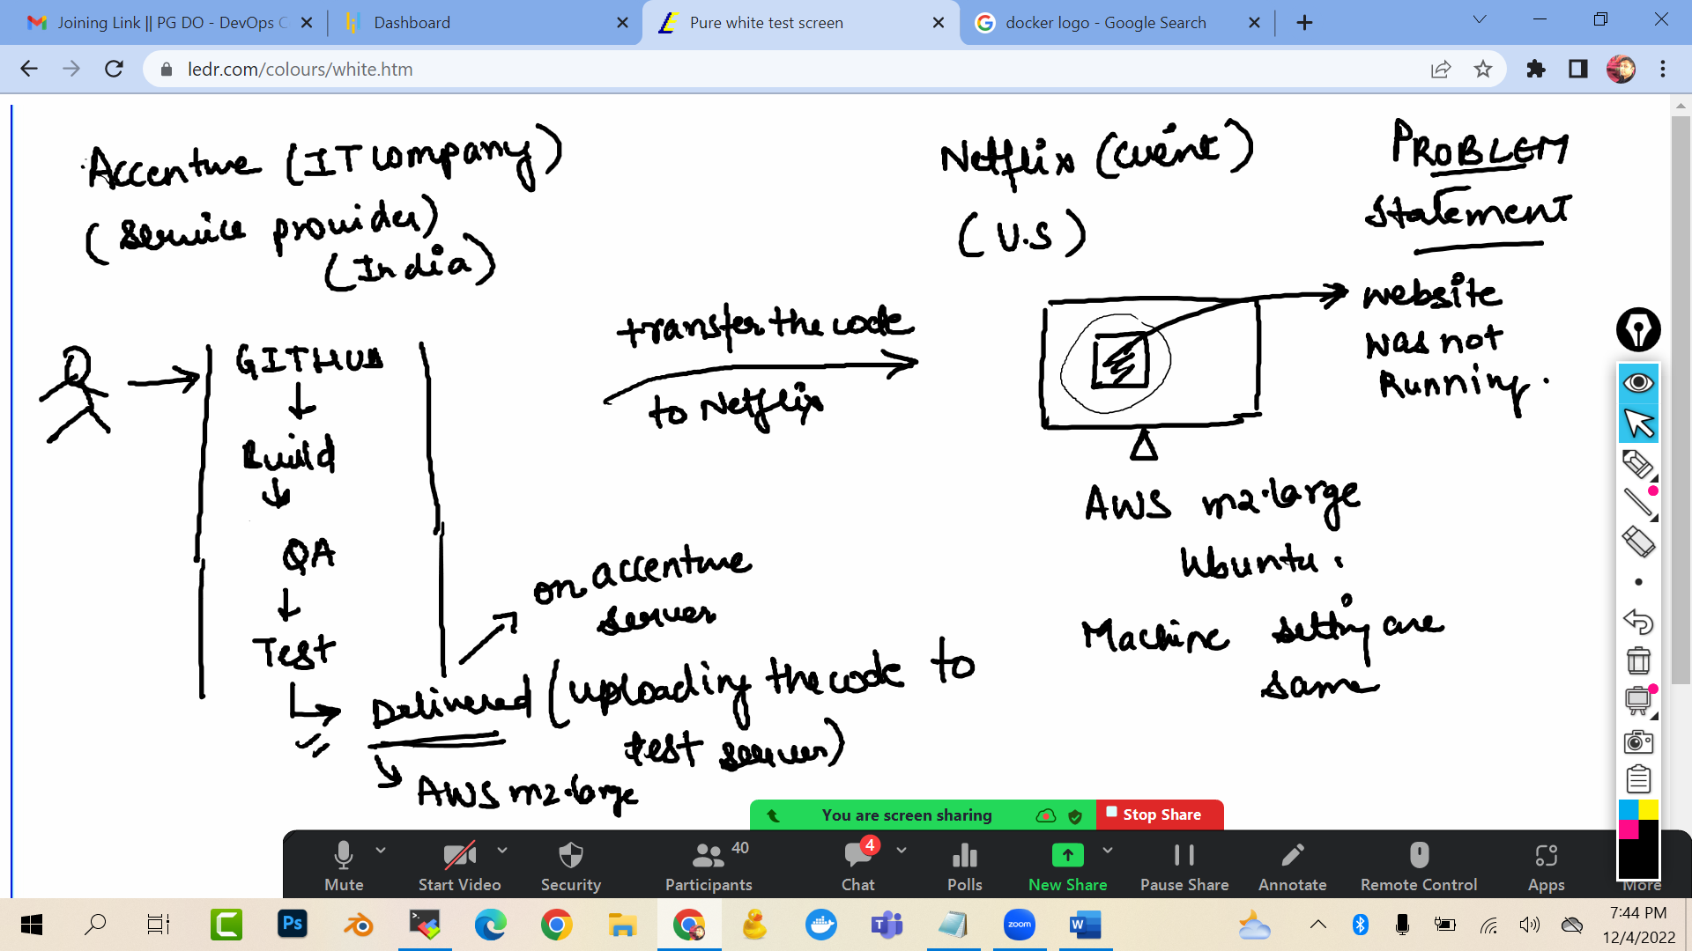

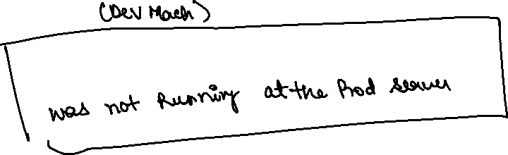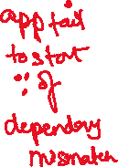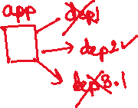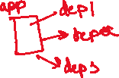

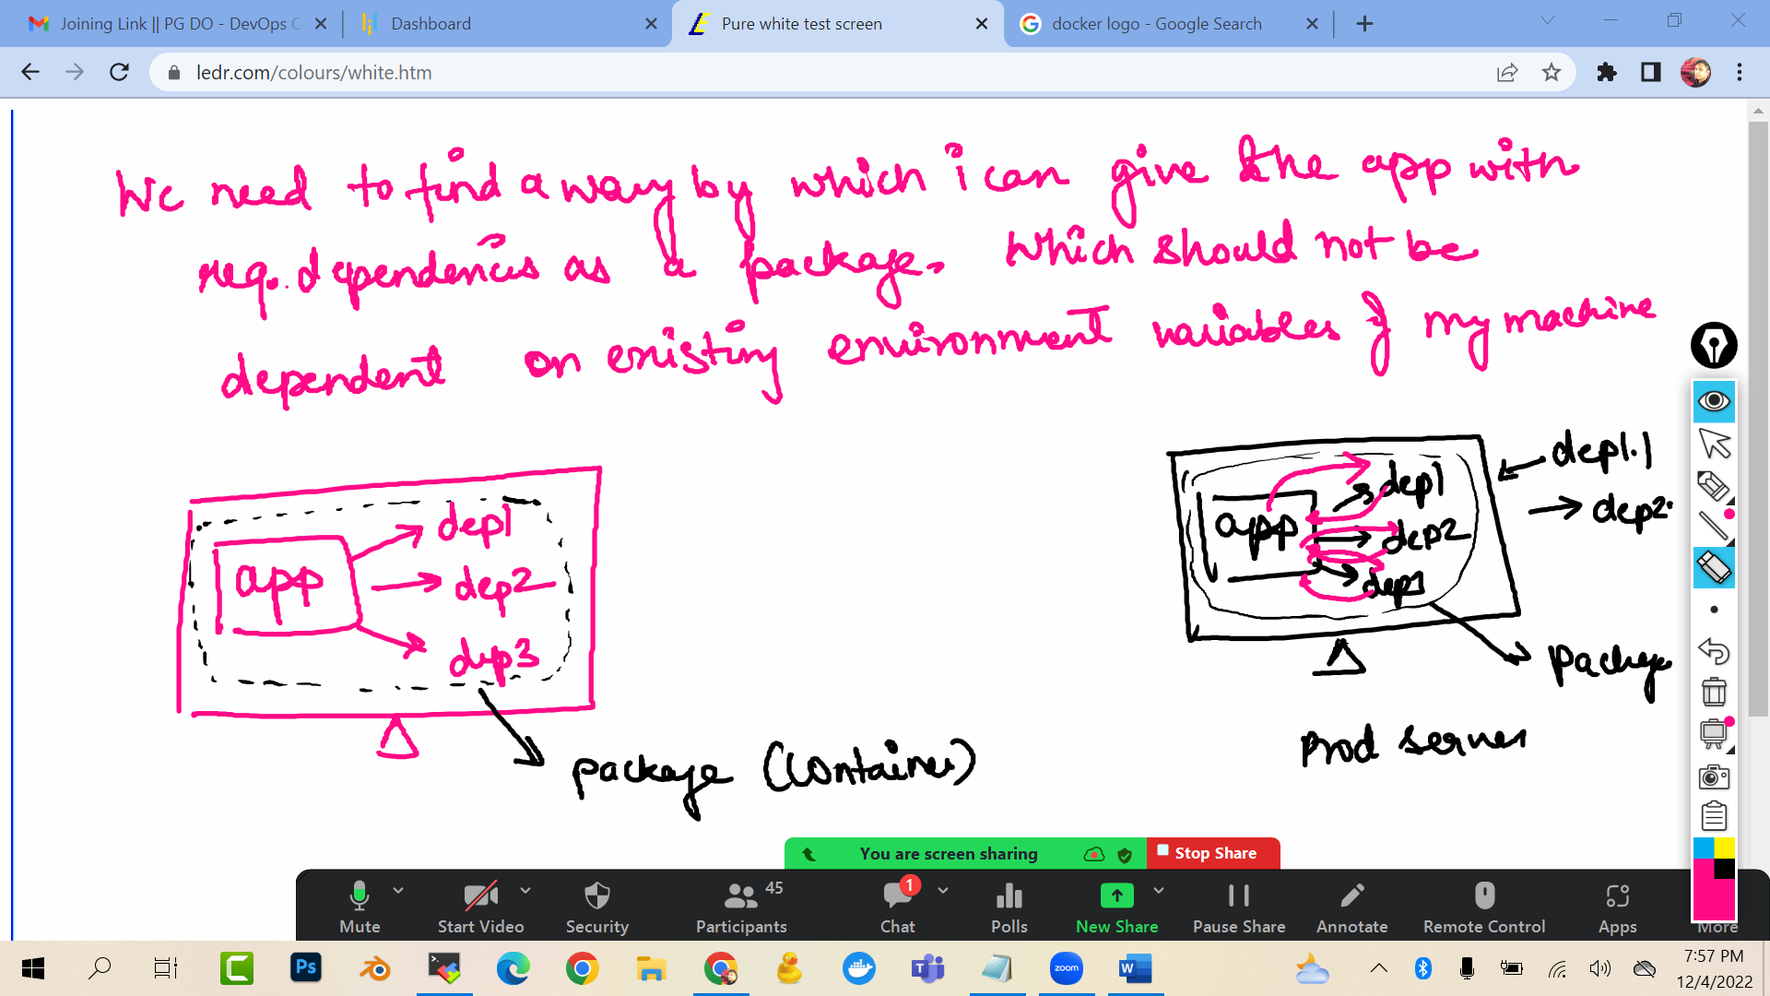

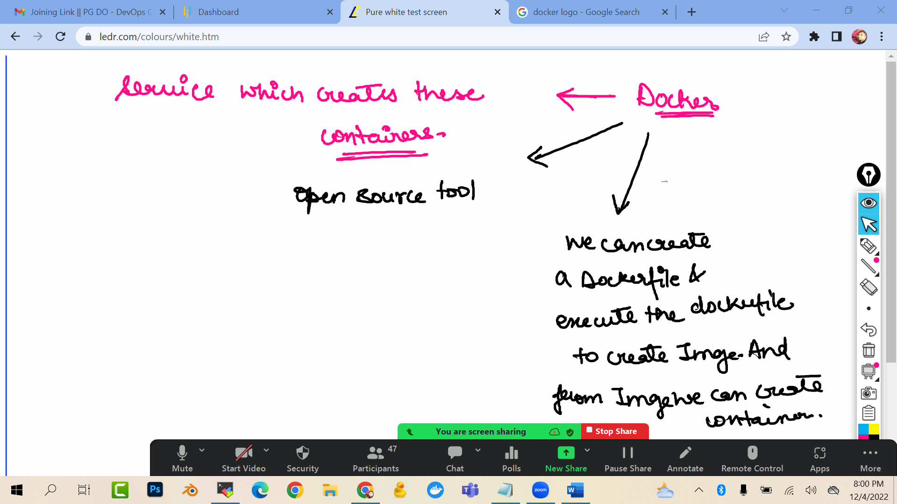

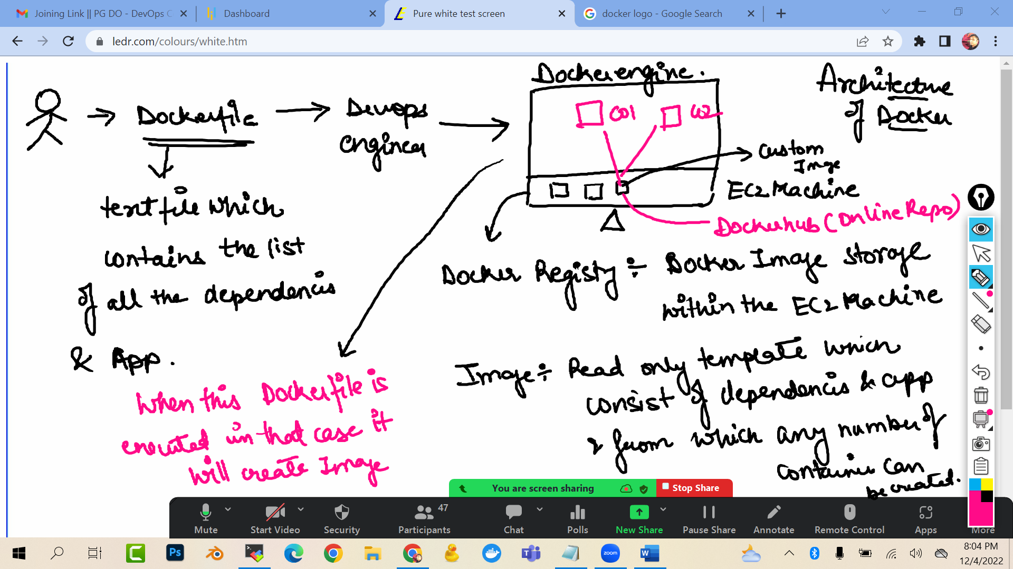

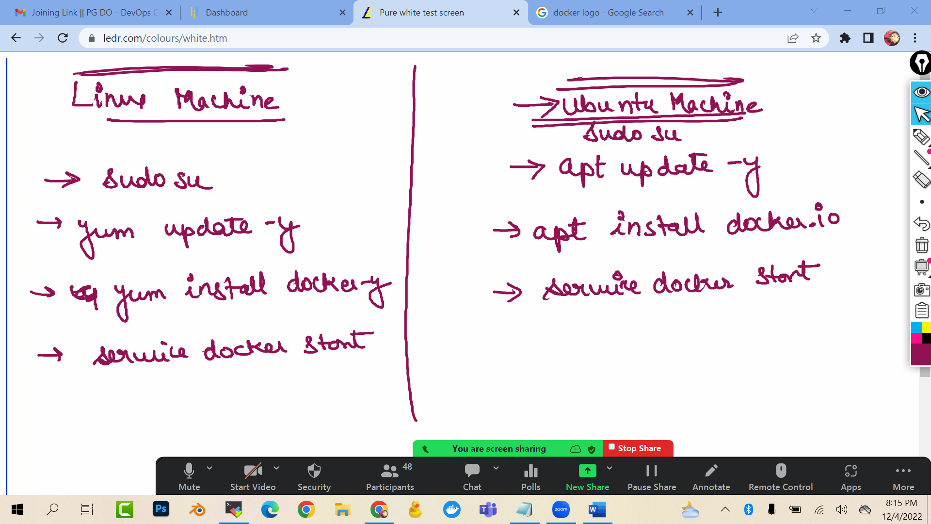

Launch a ubuntu ec2 machine

sudo su

apt update -y

apt install docker.io -y

docker --version

service docker start

service docker status

To check the images (read only template) in the docker registry (in ec2 machine)

docker images

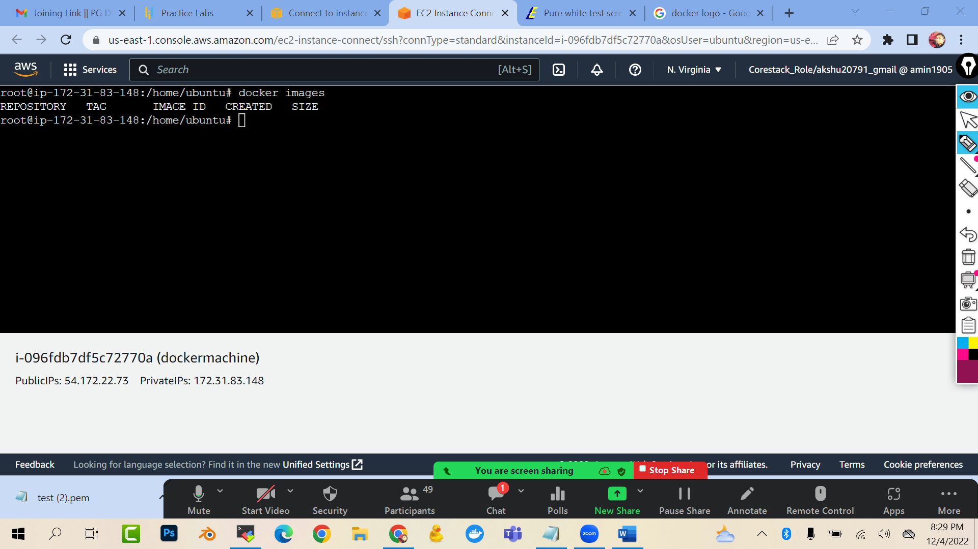

Create account on dockerhub

<https://hub.docker.com/_/redis>

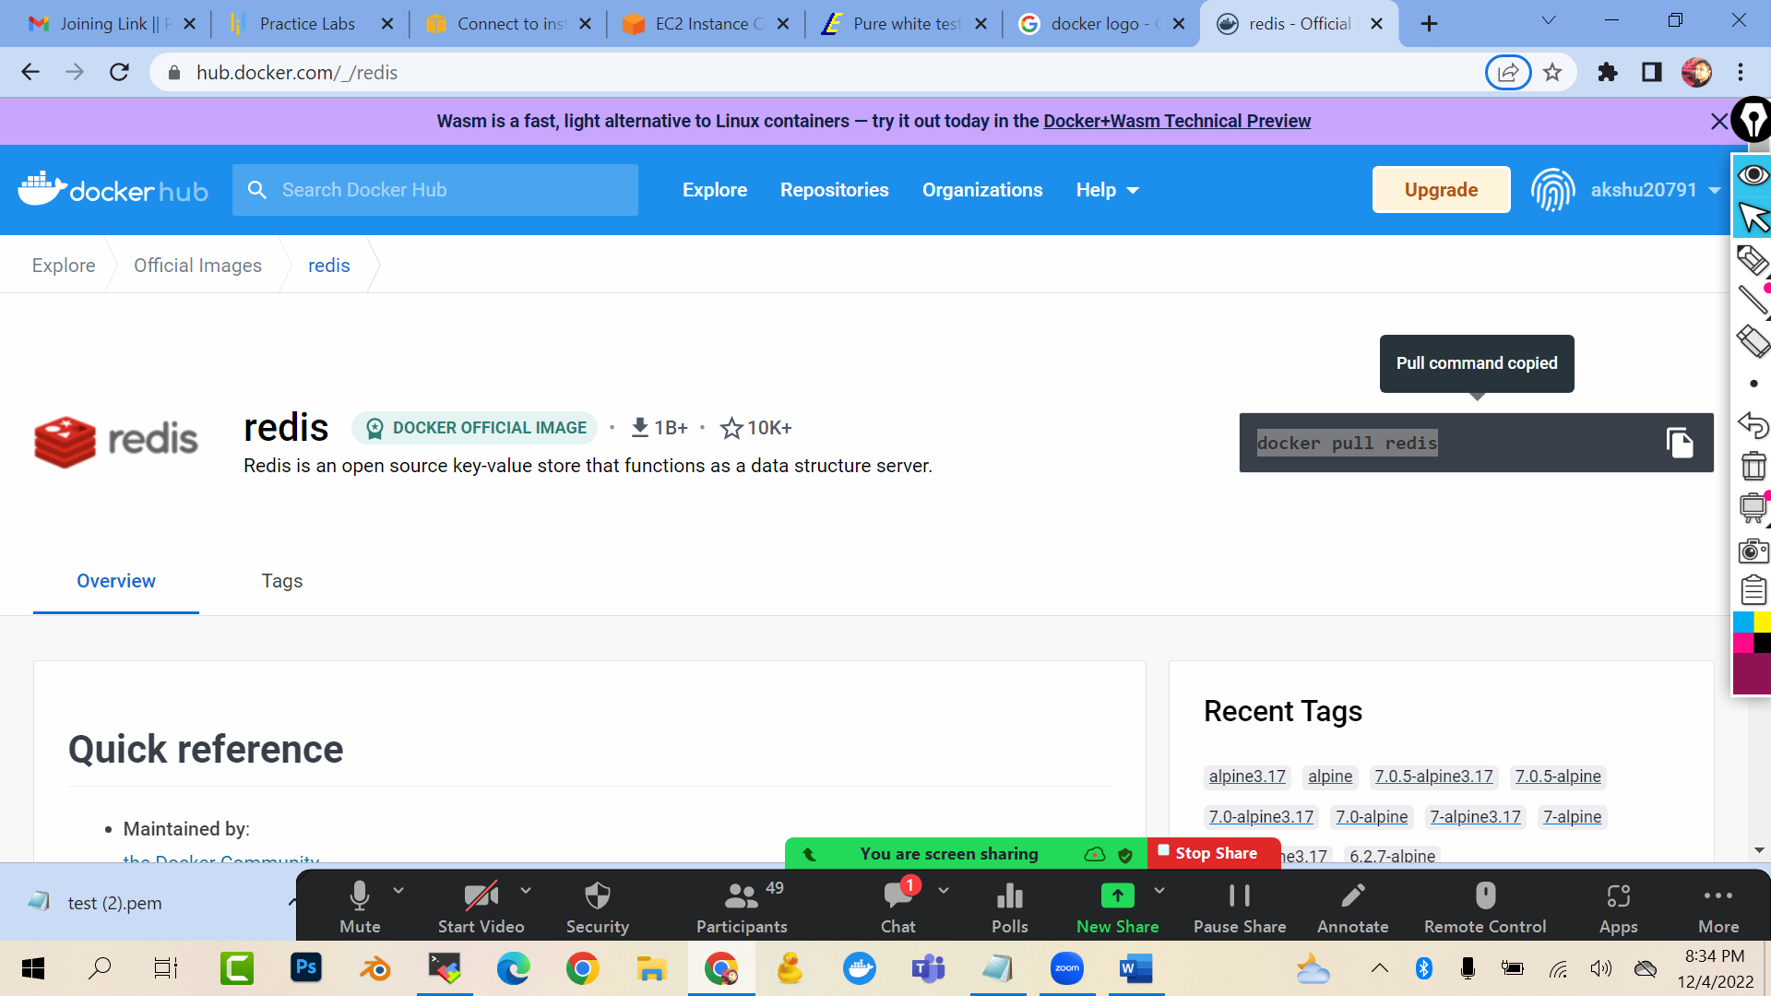

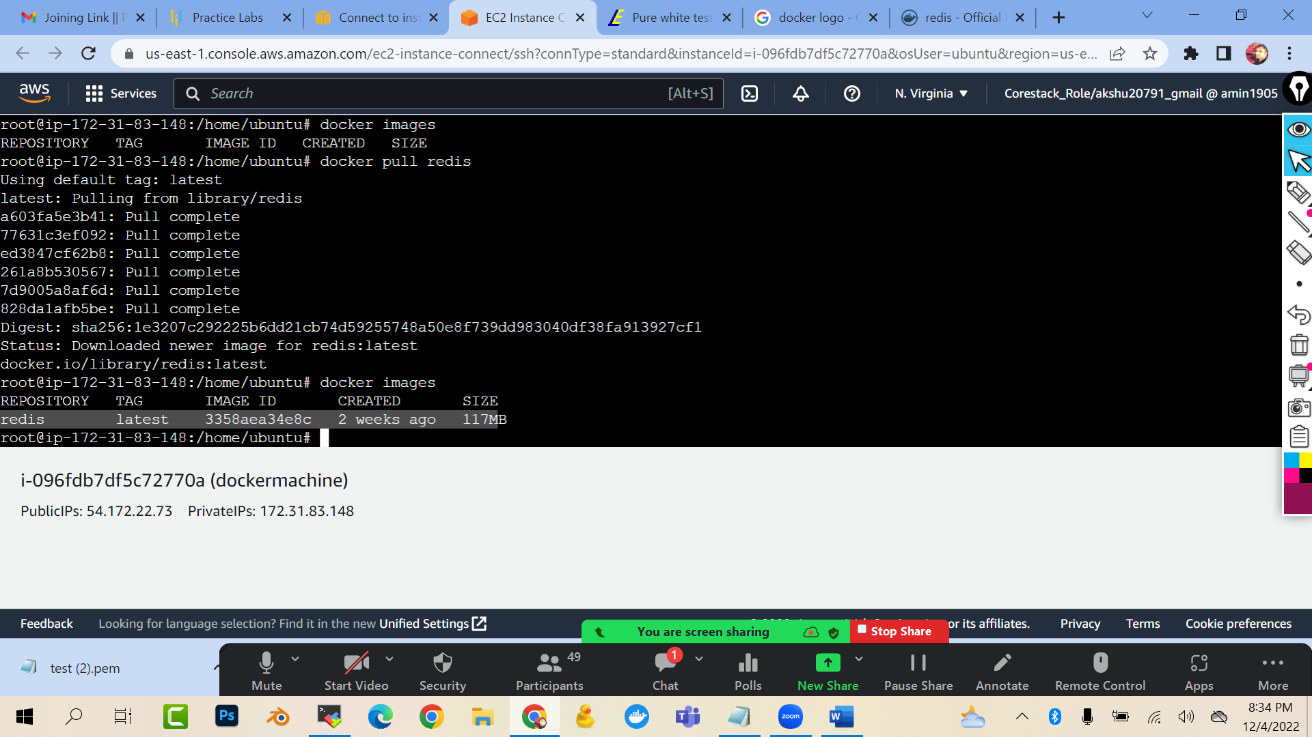

docker pull redis

docker images

### RIGHT NOW WE PULLED THE LATEST VERSION…BUT LETS SAY I DEVELOPER WANTS TO PULL THE SPECIFIC VERSION OF THE REDIS

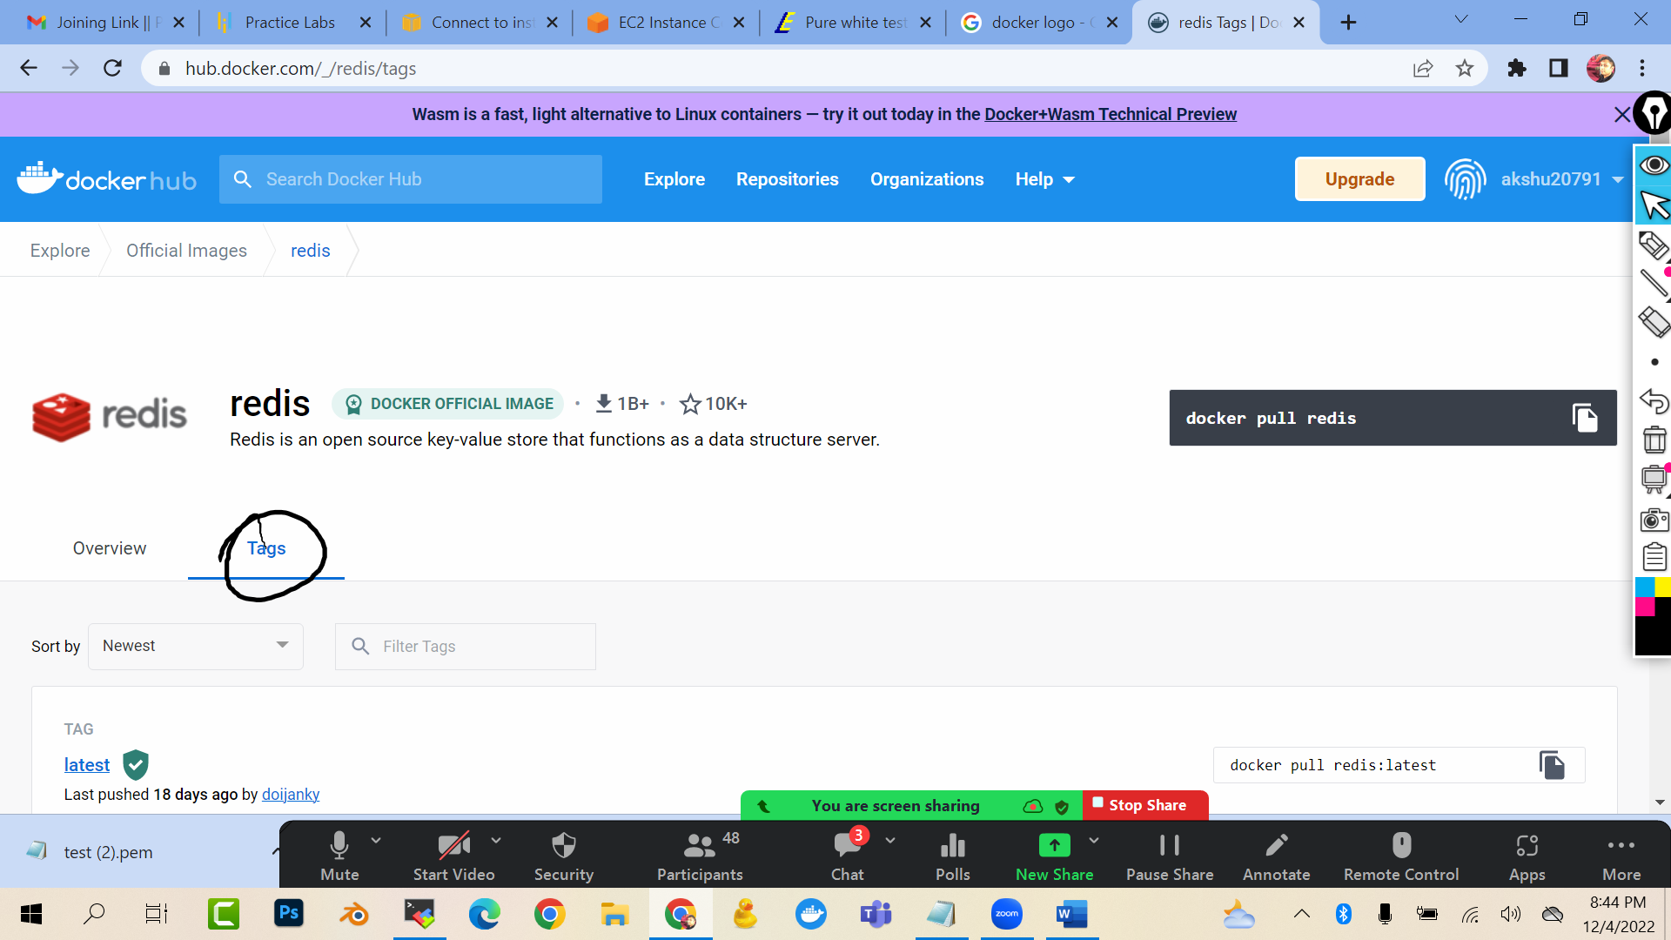

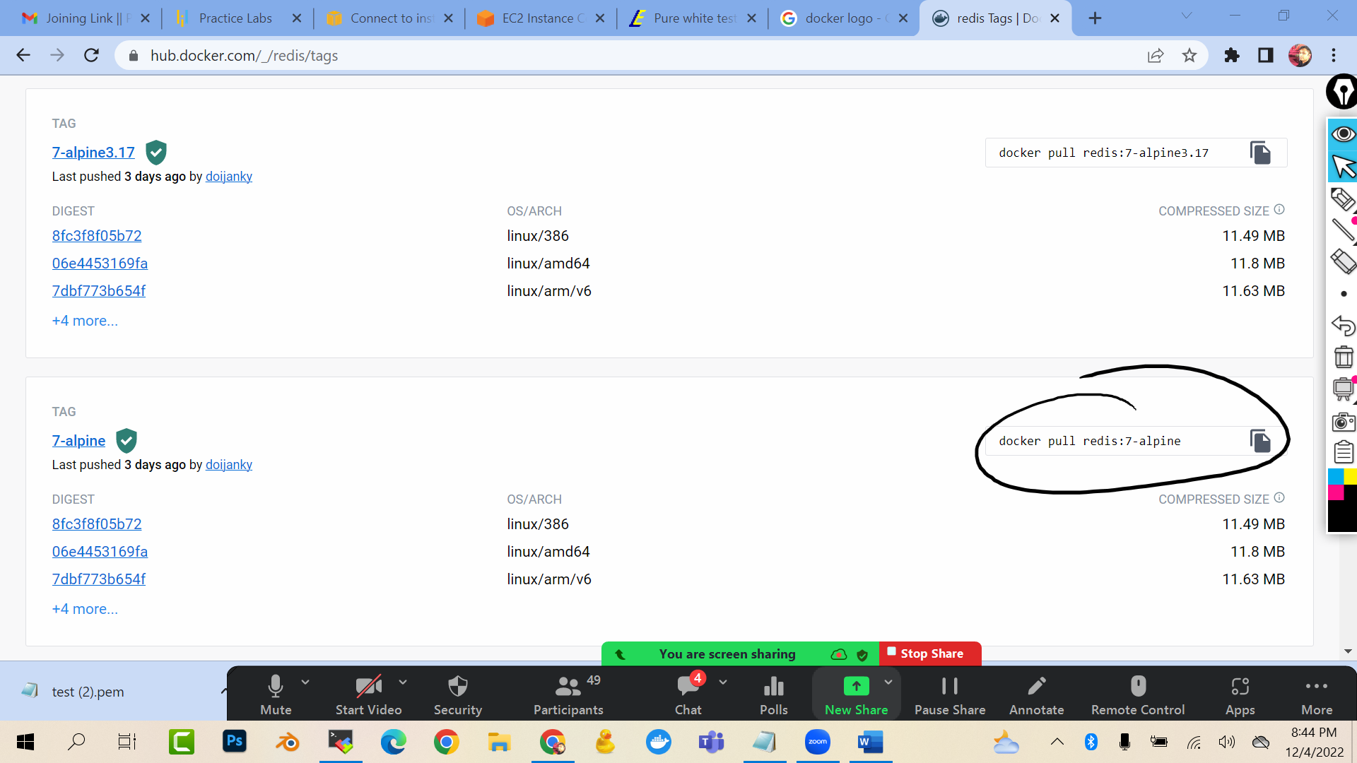

docker pull redis:7-alpine

docker images

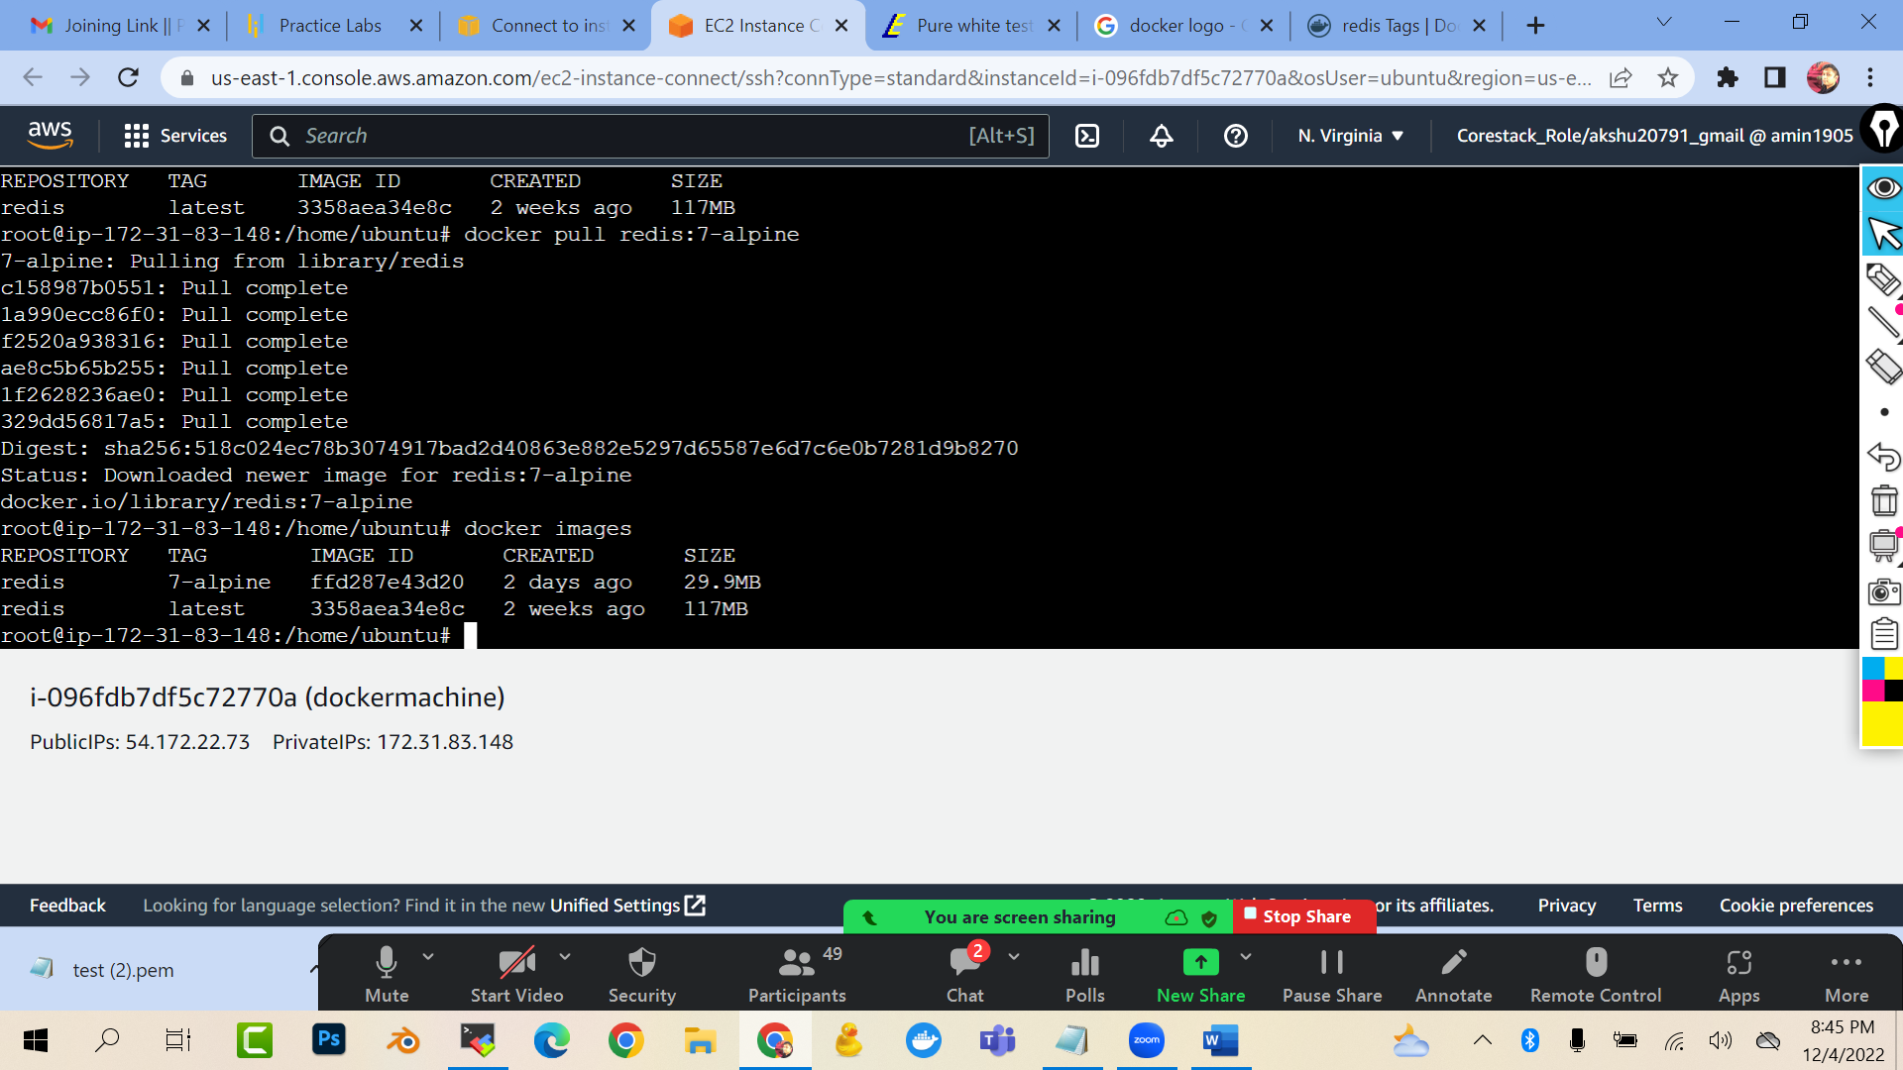

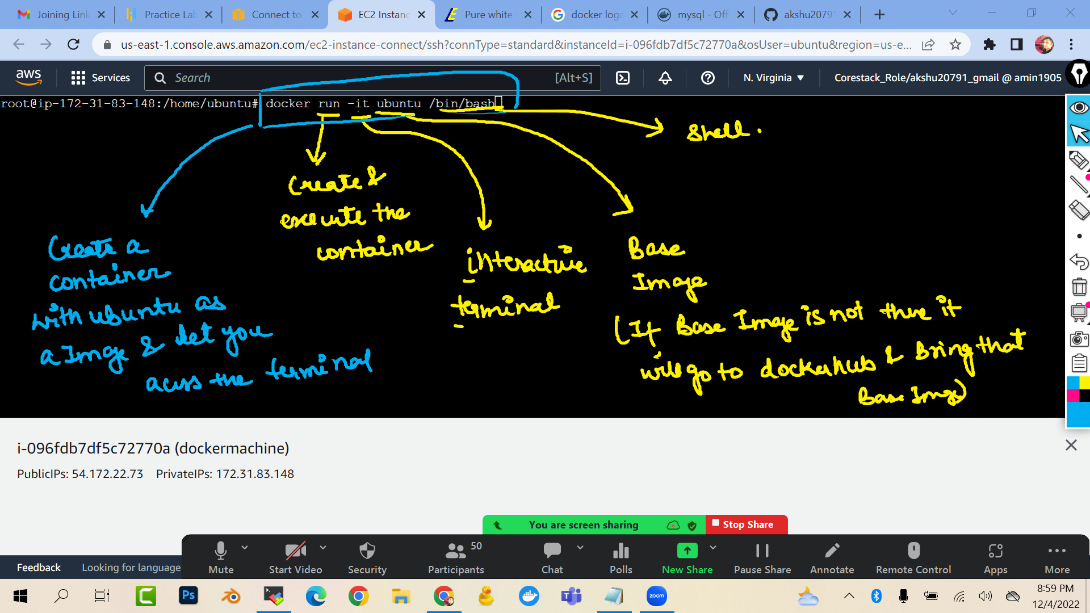

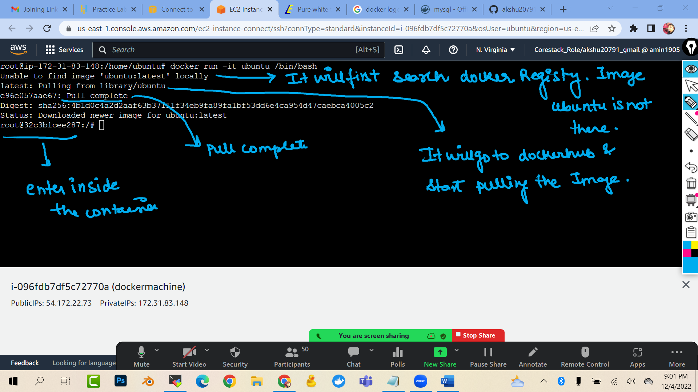

docker run -it ubuntu /bin/bash

(you will see that you have entered inside the container)

touch file1 file2 file3

ls

exit

ls

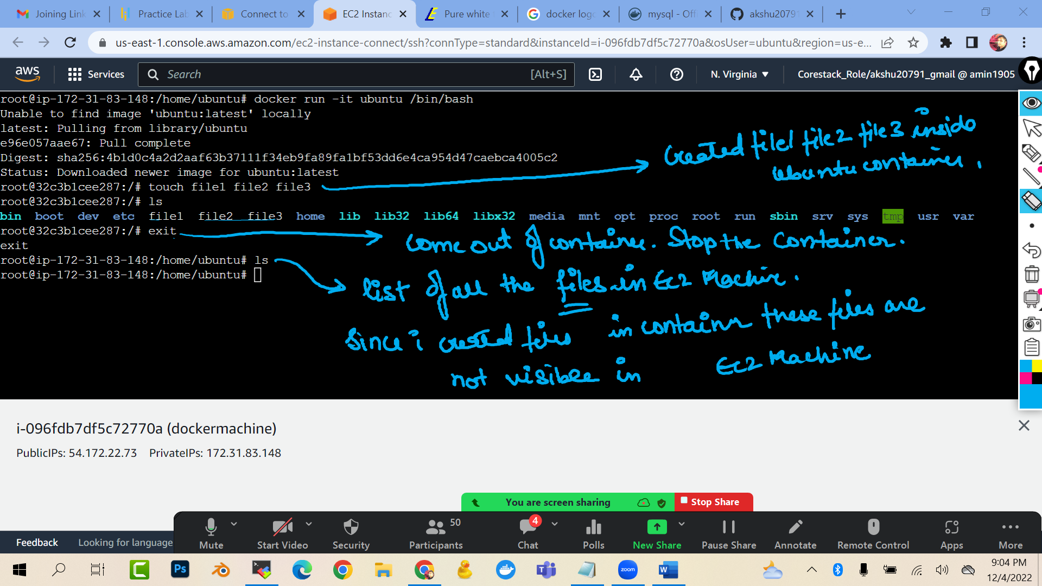

#### HOW TO LIST AND CHECK ALL THE CONTAINER ###############

docker ps -a

(ps: process)

(-a : all)

(it will list all the container for me)

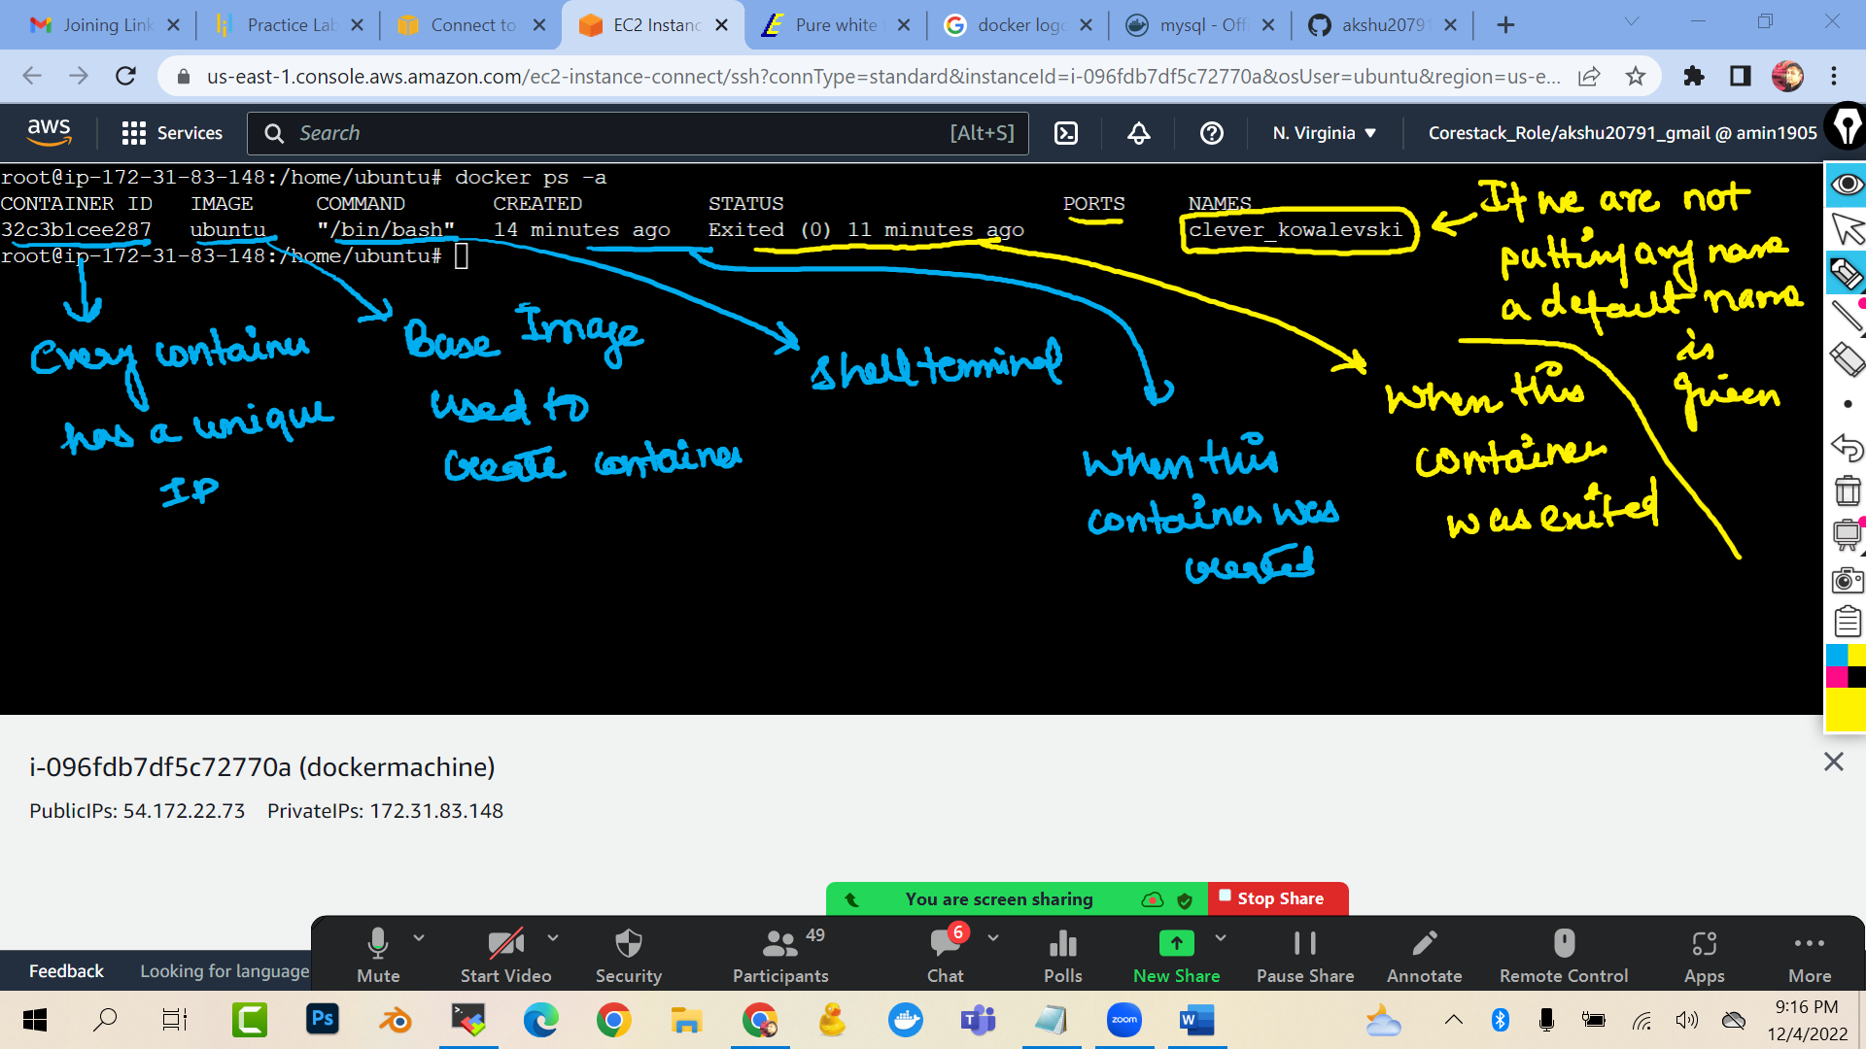

docker ps

(it will list only the running container)

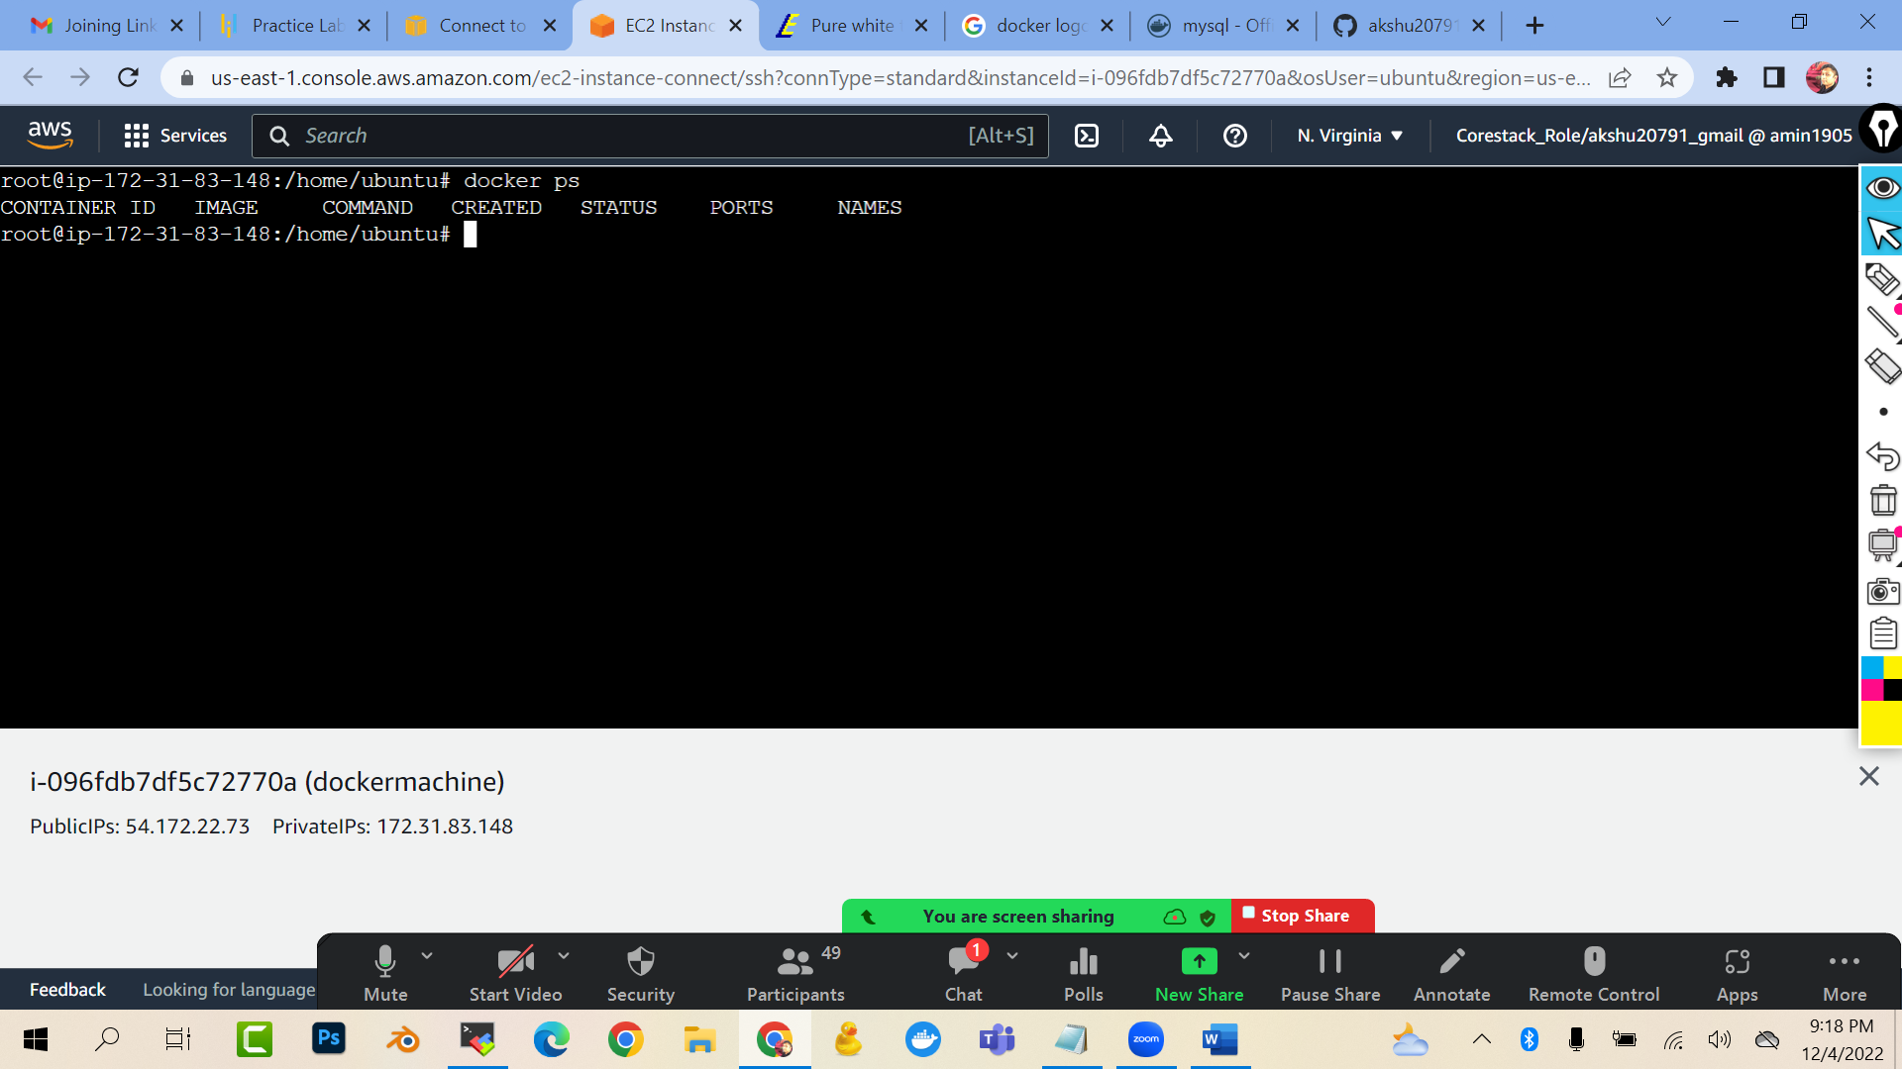

**###HOW CAN I START THE CONTAINER AND GET INSIDE THE CONTAINER ###############**

docker start <<name or id of your container>>

docker attach <<name or id of your container>>

(start : this command will start your container …attach : you will enter inside the container)

(you cannot attach to the stopped container)

